**Appendix: The Effect of Indwelling Arterial Catheters in Hemodynamically Stable Patients With Respiratory Failure: A Propensity Score Analysis**

**A. Construction of Propensity Score Model**

In this study, a propensity score model was developed to estimate likelihood of getting an IAC placement. To construct the model, we first identified an initial set of 60 covariates that potentially influence the decision for IAC placement. We then employed a Genetic Algorithm (GA) based method to shortlist a subset of covariates that optimize the performance of the propensity score model.

**A.1 Covariates Identification based on Clinical Knowledge**

The initial set of 60 covariates is as follows.

Demographic:Admission age, weight, BMI, gender, ethical group, time of admission (whether the patient was admitted to ICU between 7am to 7pm), day of admission and service unit (medical or surgical ICU).

Co-morbidities (ICD-9): Congestive Heart Failure 398.91 428.0 428.1 428.20 428.21 428.22 428.23 428.30 428.31 428.32 428.33 428.40 428.41 428.42, 428, 428.2, 428.3, 428.4, 428.43, 428.9; Atrial fibrillation 427.3*; Chronic renal disease 585.*; End stage liver disease 571.*; Chronic Obstructive Pulmonary Disease 490-496; Coronary Artery Disease 414.*; Stroke 440-434; Malignancy 140-239; Respiratory failure 518.*.

Vital sign/Hemodynamic variables: Data include Mean Arterial Pressure (MAP), temperature, heart rate, oxygen saturation (SPO2) and Central Venous Pressure (CVP).

Laboratory test results: White Blood Cell (WBC) count, Hemoglobin, Platelets, Sodium, Potasssium, Bicarbonate, Chloride, BUN, Creatinine, Glucose, Calcium, Magnesium, Phosphate, Aspartate Aminotransferase (AST), Alanine Aminotransferase (ALT), Lactic Acid Dehydrogenase (LDH), Bilirubin, Alkaline phosphatase, Albumin, Troponin T, Creatinine kinase, Brain Natriuretic Peptide (BNP), Lactate, pH, Central venous oxygen saturation (ScvO2), Partial Pressure of Oxygen (PO2) and Partial Pressure of Carbon Dioxide (PCO2).

Sedative medication use, including Midazolam, Lorazepam, Fentanyl, Dilaudid, Propafol, Dexmedetomidine.

**A.2 GA-Based Covariate Selection and Model Optimization**

A GA-based algorithm was employed to select the subset of covariates that optimizes the performance of the propensity score model.

The genetic algorithm (GA) is a heuristic algorithm inspired by a natural “survival of the fittest” selection process [1]. The GA is commonly adopted for optimization and variable selection problems, and has a wide application in computational biology, engineering, economics, manufacturing, physicals, and mathematics. This method starts with a population of candidate solutions to an optimization problem, and then gradually evolves towards better solutions through an iterative process. Typically, each solution is represented in binary as a string with each bit indicating the “on/off” status of the corresponding variable. Through the iterative process, the “fitness” of all candidate solutions or variable subsets is evaluated based on optimization criteria, and “fitter” solutions will be selected to remain and contribute to the next generation of solutions. The selected solutions based on the fitness function then randomly “mutate” (change a variable) or “breed” (exchange smaller subsets of variables with one another) to generate a new set of candidate solutions for the next iteration. The evolution/optimization process will stop when the maximum numbers of iterations or best possible solution has been achieved.

In our study, the GA R package was used to implement the optimization method [2]. We allowed the GA algorithm to evolve over 3000 iterations with 50 candidate solution sets. The GA-based optimization was guided by the following criteria:

* Maximize the average area under the Receiver Operating Characteristic (ROC) curves of the model over a 10-fold cross validation.
* Select a minimum set of covariates for the optimum performance
* Covariates with large amount of missing data are less favorable

**A.3 Finaliz Propensity Score Model**

The finaliz propensity score model consists of 29 covariates as shown in Table 1. The odds ratios indicate the associations between the covariates and the likelihood of getting IAC placement. Figure 1 demonstrates that, over a 10-fold cross validation, the average area under the ROC curve of the final model is 0.81. This indicates a stable performance of the final model.

Table 1 Finalized Propensity Score Model

|  |  |  |  |  |
| --- | --- | --- | --- | --- |
|  | **Odds Ratio** | **[95% Conf.** | **Interval]** | **p-value** |
| **Age** | 0.997 | 0.988 | 1.005 | 0.426 |
| **Weight\*** | 1.001 | 0.995 | 1.007 | 0.761 |
| **SOFA** | 1.591 | 1.469 | 1.723 | 0.000 |
| **MICU (ref) vs CSRU** | 7.216 | 5.310 | 9.805 | 0.000 |
| **Day-of-ICU-Adm (Sunday as ref.)** |  |  |  |  |
| Monday | 1.504 | 0.923 | 2.450 | 0.101 |
| Tuesday | 1.183 | 0.737 | 1.899 | 0.486 |
| Wednesday | 1.575 | 0.970 | 2.558 | 0.066 |
| Thursday | 1.492 | 0.922 | 2.415 | 0.104 |
| Friday | 1.904 | 1.151 | 3.148 | 0.012 |
| Saturday | 1.128 | 0.710 | 1.793 | 0.611 |
| **Chronic Co-morbidities** |  |  |  |  |
| CHF | 1.780 | 1.091 | 2.904 | 0.021 |
| A-fib | 0.978 | 0.623 | 1.535 | 0.922 |
| Chronic Renal Disease | 1.537 | 0.703 | 3.360 | 0.281 |
| End-stage Liver Disease | 0.360 | 0.192 | 0.676 | 0.001 |
| COPD | 0.784 | 0.488 | 1.259 | 0.314 |
| CAD | 0.958 | 0.544 | 1.688 | 0.883 |
| Stroke | 1.382 | 0.873 | 2.189 | 0.168 |
| Malignancy | 1.160 | 0.785 | 1.713 | 0.456 |
| Respiratory Failure | 1.016 | 0.746 | 1.385 | 0.918 |
| **Vital Signs** |  |  |  |  |
| Mean Arterial Pressure* | 1.007 | 1.000 | 1.015 | 0.054 |
| Heart Rate* | 1.006 | 0.999 | 1.014 | 0.098 |
| SPO2* | 0.974 | 0.947 | 1.001 | 0.063 |
| Temperature* | 1.000 | 0.972 | 1.029 | 0.988 |
| **Lab Tests** |  |  |  |  |
| White Blood Cell* | 1.032 | 1.009 | 1.056 | 0.006 |
| Hemoglobin* | 0.954 | 0.888 | 1.024 | 0.191 |
| Platelet* | 1.000 | 0.998 | 1.001 | 0.726 |
| Sodium* | 0.930 | 0.892 | 0.969 | 0.001 |
| Potassium* | 1.022 | 0.863 | 1.211 | 0.799 |
| Bicarbonate* | 1.023 | 0.990 | 1.058 | 0.177 |
| Chloride* | 1.055 | 1.018 | 1.093 | 0.003 |
| BUN* | 1.006 | 0.993 | 1.019 | 0.376 |
| Creatinine* | 0.763 | 0.637 | 0.915 | 0.003 |
| PO2* | 1.001 | 1.000 | 1.002 | 0.134 |
| PCO2* | 0.996 | 0.984 | 1.007 | 0.462 |

* The first values during patients’ ICU stay of these covariates were used in the final model.

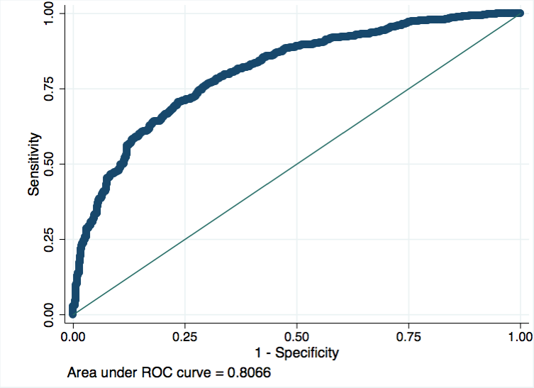

Figure 1 Average ROC curve of the finalized Propensity Score Model over 10-fold cross-validation.

**Reference**:

[1] Mitchell, Melanie (1996). An Introduction to Genetic Algorithms. Cambridge, MA: MIT Press.

[2] http://cran.r-project.org/web/packages/GA/index.html